**Leveraging technology to create value**

**for fine-motor skills development**

**Background**

Developing and Improving fine-motor skills requires the individual to perform repetitive exercises or movements to activate neuroplasticity (how your brain wires itself while learning new skills) and master these skills.

Two particular populations deal with the need of activating this neuroplasticity to (re-)develop or improve their fine-motors skills: toddlers, who are in the process of learning handwriting and patients recovering from a stroke, who need to regain those fine-motors skills for their daily activities.  
  
Both educational and health centers normally work with the kids and patients providing them with exercises; however, the in-person time with them is limited. Thus, it is very common that kids and patients are given exercises to perform at home. The two biggest challenges of these in-home exercises are providing proper feedback and maintain the individual engagement on the activity. Kids and patients are, most of the time, by themselves or even when they have someone assisting them with the exercises this companion might not have the needed experience to provide accurate feedback; also, since these exercises repetitive, it is very easy that the individual lose the interest in them.   
  
In an effort to support these in-home activities, particularly improving the feedback process and maintaining high engagement, it is suggested to implement some of these activities using technology, such as low-cost easy-access game-based computer applications. Through these applications, it is possible to induce and maintain engagement and provided proper feedback to the user (either a kid or an adult patient).

**Description of the project**

In this project, you will work on the implementation of a **web-based application** to support individuals on their effort to develop or improve their fine-motor skills. This application could have a high impact on toddlers dealing with the development of fine-motor skills needed to learn handwriting as well on patients recovering from a stroke to recover their fine-motors skills needed for their daily activities.   
  
This application should include at least **three different exercises** for the user to “play” with them. Each exercise should provide proper feedback to the user, this feedback could use both visual and audio components.

**Final user and problem statement**

As mentioned before, this type of applications can benefit both toddlers learning new fine-motor skills needed to learn handwriting as well as patients recovering from a stroke that need to improve / recover their fine-motors skills.

Your team should **define who your final user** will be. Defining your final user, should and will help you better define the particular exercises that you will include in your application as well as the type of feedback and instructions you will include as part of your application particularly this help you to define the complexity level of the vocabulary and diverse components to engage your user.

Once you define your final user, you want to **improve the problem statement** of your project. You can use the general problem statement provided in the general description of the project as staring point.

You need to provide both the problem statement and the customer archetype, you can use the questions below as guidance.

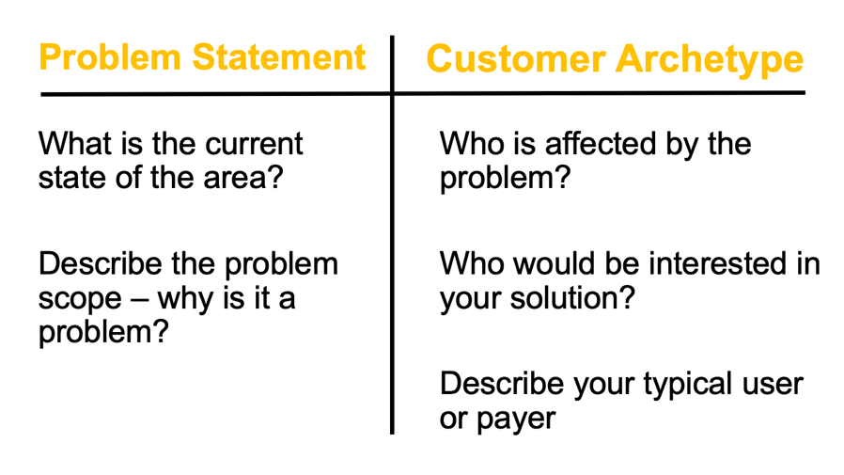

**Analyze the customer pain points**

Now that we defined our final user, our customer, the next steps would be to:

* Analyze the customer pain points
* Create potential solutions for those pain points

To get some more awareness of the need and possible pain points of our client, consider the following:

* Think on the different activities that require fine-motor skills on your daily life, e.g., picking coins, piling coins, put the shoe laces on a shoe, button up your shirt, the usage of a calculator or phone where you have to tap on “small” buttons, etc.

Below are some examples of these pain points, that you can use as a starting point.

|  |  |
| --- | --- |
| Activity | Challenge |
| Picking coins | * Reach a specific coin * Reach the rim of the coin to actually pick it * Take it off the surface |
| Piling coins | * Reach a specific coin * Reach the rim of the coin to actually pick it * Take the coin off the surface * Put the coin on the top of the pile * Form the pile |

You need to think about pain points, to create potential solutions and then to validate this pain points and solutions with our customer. Keep in mind that in this particular case, you want to identify those potential exercises to include in your app that will help the user to improve the fine motor skills needed to perform that particular activity, as well as the proper way to implement an activity in the that allows practice that skill, and how this activity in the app offers them an added value compared with other activities they already do at home or in physical therapy facilities with or without technology / apps.

As an example, for the first pain point above, “Picking coins”, the challenge for the individual includes from reaching to the coin, to put together the fingers to pick the coin. So, in order to improve / develop this fine-motor skill, a solution could be to have the user to reach out to a figure (e.g., a circle) and when the user reach it the figure can change the color, then the user should do a pinch with the index and thumb fingers to pick up the coin, when this is correct the figure could change again the color and/or have a sound as part of the feedback as well, then the user can move the figure to a different goal position on the screen, and when the figure is in the right position, there could be another change on color and sound as feedback.

A good practice to avoid assuming pain points and / or the solution you are considering, is to talk with our customer and have an interview with them and make sure that we understand their pain points. When defining the pain points and solutions, a good best practice is to implement the three C’s: curiosity, connections, and creating value. Each of these C’s offers some questions to help to identify the pain points and possible solutions.

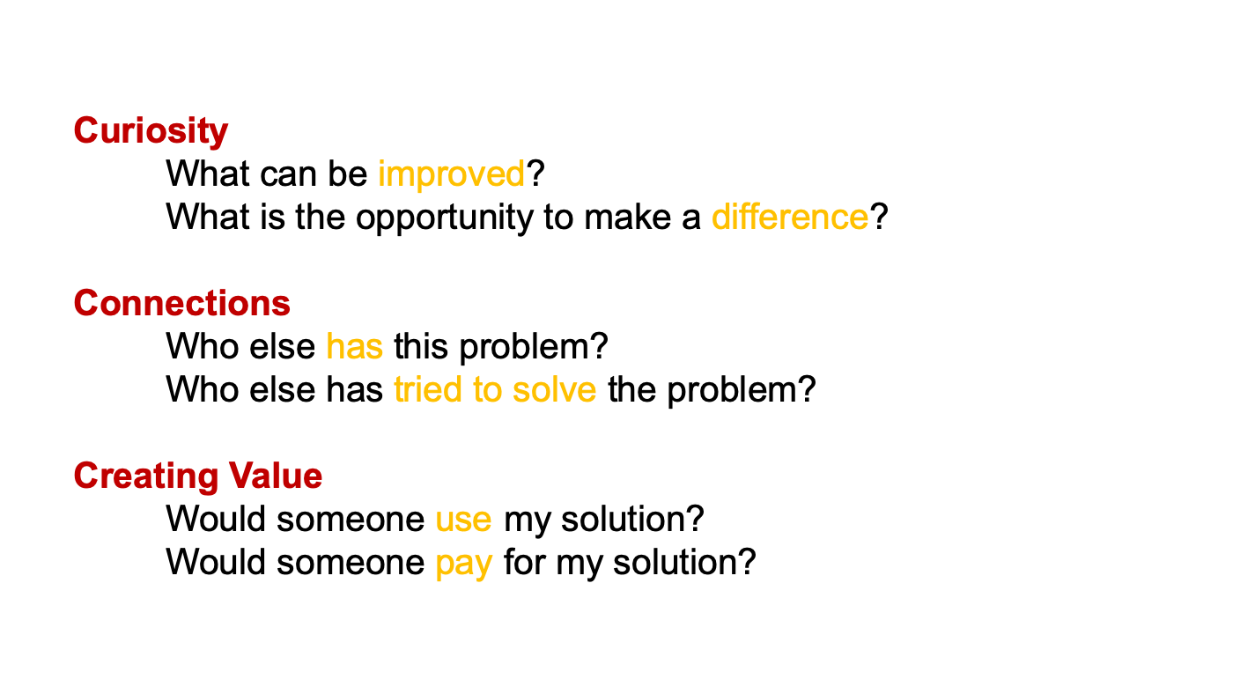

Once you have the list of pain points and potential solutions, you need to validate them with the customer. When talking with the customer, we want to have a questionnaire to interview them. In order to create this questionnaire, we want can consider the following:

* Ask them if the pain points you identified are really pain points for them.
* For those pain points validated as such, ask them whether they have a solution for them. As a reminder, you are trying to identify tasks that can be implemented in your app that help them to improve a particular fine-motor skill.
* If they have a current solution (potentially a physical activity / exercise):
  + Ask them how much they like the current solution.
  + Also, you are interested on learning how they find this solution.
  + You are also interested on learning how much they like that solution or what they might want to change.
  + Another piece of information we want to learn is how much our customer is willing to pay for that solution. This should help you to discover what should / could be your added value to engage the user.
* If they don’t have a solution:
  + Ask them if they have tried something already, they might have in place some sort of activities that helps them to improve those fine-motor skills.
  + If so, ask them how that solution could be improved.
  + Ask them what could be a better solution. You don’t want to give / share too much details on your own solution as you don’t want to create a bias.

The first four steps to complete on your development, includes:

1. Define the **final user to** work with, either toddlers or patients recovering from a stroke.
2. Improve the **problem statement** given above accordingly with the final user you selected.
3. Perform the **customer discovery** process to learn as much as possible from the pain points or needs of the selected final user. This should be via research and/or direct interviews with final users. This includes:
   * Create the list of what you consider could be pain points for your final user.
   * Define questions for interviewing our user.
   * Review and assess the paint points for your final user. Make a table where you include 10 of those pain points / activities, take a photo of yourself or your teammate performing this activity. Include in the table, what could be the challenge for someone with limited motor-skills. You can follow the examples provided in the description of the project. And you should provide how the task in your application might / could looks like.
4. Define the **requirements** for your application.